User and Permission Management
What is a User?
A user is a person or account that can log in and use the Linux system.
Examples:
- Student
- Teacher
- Administrator
Just like a classroom has many students, a Linux system can have many users.

Types of Users
1. Root User
- Superuser of Linux.
- Has full control over the system.
- Can create, modify, and delete anything.
Example:
root
Commands root can run:
useradd student
passwd student
rm -rf /folder
⚠️ Root has unlimited permissions.

Have permission of /sbin →
Contains essential system administration commands used mainly by the root/admin user.
- Examples: fdisk, mkfs, shutdown, reboot
And /bin permission too

2. Regular User
- Normal user account.
- Limited permissions.
- Cannot change important system files.
Example:
student
ubuntu
john
Can:
- Create files
- Edit files
- Run programs
Cannot:
- Install software (without sudo)
- Manage other users
Have permission of /bin
→ Contains essential daily commands used by all users.
- Examples: ls, cp, mv, cat, mkdir

3. System User
- Created by Linux automatically.
- Used by services and applications.
Examples:
www-data
mysql
nobody
These users are not meant for normal login.

Check Current User
Command:
whoami
Example Output:
student
👉 Shows currently logged-in user.

View Logged-In Users
Command:
who
Example Output:
student tty1
admin pts/0
👉 Shows users currently logged into the system.

View All Users
Command:
cat /etc/passwd
Example Output:
root:x:0:0:root:/root:/bin/bash
student:x:1001:1001::/home/student:/bin/bash
👉 Displays all users on the system.

Quick Revision
User Type | Description
Root User | Full control over system
Regular User | Normal user with limited access
System User | Used by services/applications

Command | Purpose
whoami | Show current user
who | Show logged-in users
cat /etc/passwd | Show all users
- User Creation (useradd)
- Password Management (passwd)
- User Deletion (userdel)
# id
uid=0(root) gid=0(root) groups=0(root)
Meaning:
- uid=0(root) → User ID 0 = Root user
- gid=0(root) → Group ID 0 = Root group
- groups=0(root) → You belong to the root group
For most modern distributions like Ubuntu, Kali, and RHEL 7+:
- Root (Super User) → UID 0
- System Users → UID 1–999
- Local/Normal Users → UID 1000+
Example:
root UID=0
sshd UID=74
mysql UID=27
raju UID=1000
Root user has UID 0. System users have UIDs from 1–999. Local (normal) users have UIDs starting from 1000 and above.
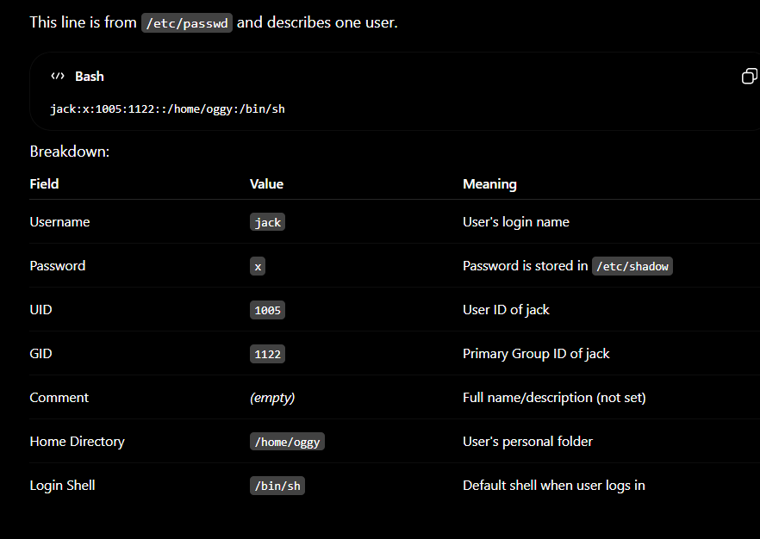
Create user with comment
sudo useradd -c "Jack Sparrow" jack
or
sudo useradd -m -s /bin/bash -c "add jack" jack
now change everything
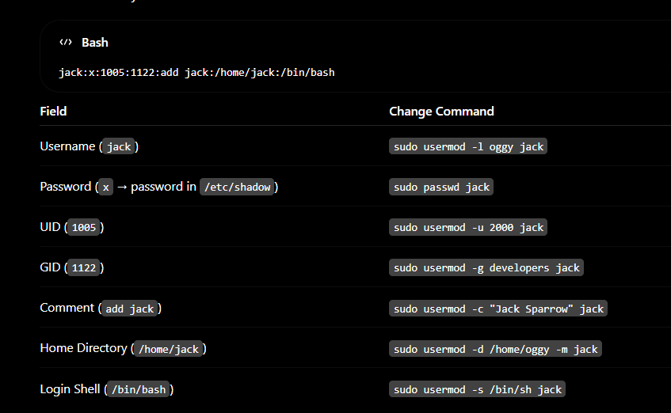

How to add an user?
Two ways to add an user
useradd
- Low-level command
- Creates the user account only
- You may need to manually set password, home directory, etc.
Example:
sudo useradd raju
sudo passwd raju
adduser
- Higher-level, user-friendly script
- Asks for password and user details interactively
- Creates home directory and sets things automatically
Example:
sudo adduser raju
It will ask:
Password:
Full Name:
Room Number:
Etc

Where user password is stored ?
The user's password (stored as an encrypted hash) is located in /etc/shadow.

How to login in user
Switch user and login as that user.
So:
- su username → Switch user
- su - username → Switch user with login environment

Groups in linux
When you create a user (especially with useradd/adduser default settings):
- A primary group is usually created with the same name as the user.
- The user is added to that group.
Example:
User: raju
Primary Group: raju
Group information is stored in:
/etc/group

- /etc/passwd → User details
- /etc/shadow → Password hashes
- /etc/group → Group details
- /etc/gshadow → Group passwords/security
- /etc/skel → Default files for new users (.bashrc, .bash_logout, .bash_profile)
/etc/skel/.bashrc → /home/raju/.bashrc
/etc/skel/.bash_profile → /home/raju/.bash_profile
/etc/skel/.bash_logout → /home/raju/.bash_logout
/etc/skel contains skeleton (default) files that are copied to a user's home directory when a new user is created.

Real command of adding user
useradd -m -s /bin/bash raju
Explanation:
- useradd → Create a new user
- -m → Create the user's home directory (/home/raju)
- -s /bin/bash → Assign Bash as the user's login shell
- raju → Username
You can teach it like this:
-m creates the user's home directory, and -s /bin/bash gives the user a Bash shell so they can log in and execute commands.
1. Create a Group
groupadd dev
✅ Creates a group named dev

2. Add User to Group (Secondary Group)
usermod -aG dev raju
✅ Adds raju to dev group

3. Make Group Primary
usermod -g dev raju
✅ Makes dev the primary group of raju

4. Check User Groups
id raju
or
groups raju

5. Set Password on a Group
gpasswd dev
✅ Sets a password for the dev group

6. Remove Group Password
gpasswd -r dev
✅ Removes the group password

7. Add Group Administrator
gpasswd -A alex dev
✅ Makes alex admin of the dev group

8. Add User to Group Using gpasswd
gpasswd -a raju dev
✅ Adds raju to dev

9. Remove User From Group
gpasswd -d raju dev
✅ Removes raju from dev

Easy Exam Notes
groupadd dev -> Create group
usermod -aG dev raju -> Add user to secondary group
usermod -g dev raju -> Make group primary
gpasswd dev -> Set group password
gpasswd -a raju dev -> Add user to group
gpasswd -d raju dev -> Remove user from group
groups raju -> Show groups
id raju -> Show UID, GID, groups
✅ Remember:
- -g = Primary Group
- -G = Secondary Groups
- -aG = Add to Secondary Group without removing existing groups.
If users wants to work in secondary group?

Example:
Alex
Primary Group = devops
Secondary Group = cloud
Normally:
touch file1
File gets group:
alex devops file1
Because devops is Alex's primary/active group.

Now Alex needs to work on a Cloud project:
newgrp cloud
Then:
touch file2
File gets group:
alex cloud file2
So Alex can work with both groups because:
- Primary group = default group
- Secondary group = extra access
- newgrp cloud = temporarily make Cloud the active group
Simple student explanation
A user can belong to one primary group and many secondary groups.
Secondary groups give extra permissions.
If the user wants to work under a secondary group, they can use newgrp groupname to make that group active temporarily.
